## Merchant Name *Pipe17* Implementation POC: Royce *(IM to fill)* CX POC: *[IMP to Add]*

### 

### 

| Notes Sections   *(AE to fill if they have, Implementation to be completion DRI on handoff)*   * Info on how merchant bills  Contracts: - Subscription Fee - Usage Complexity: discounts, payment terms, amendments, upsells (30% of revenue)  1) What is the merchant temperament?  Kathleen- likes Tabs but into the nitty gritty and holds her cards close Akash- super chill and loves Tabs. Totally gets the vision. Champion   3) What are the Tabs features that the key POC cares about?   * Automated invoice creation + calculation * Accurate Reporting and Rev Rec- they will want MRR reporting. They know we don’t have this out of the box today so we’d need to provide an export to them. I told them we’re doubling down on reporting this Q * Automated dunning, cash app and collections |
| --- |

### Billing model *(Entire Section: Implementation to fill section)*

* Are there unique things about the customer creation process for this merchant?
* Information on how merchant bills
* How contract is broken up
* One off things to know about the merchant

### Contract Processing Steps *(Entire Section: Implementation/Success to fill Post-Go Live)*

### 

### **~~Customer Creation~~**

* ~~Customers should exist in Tabs from QBO but please create if not available~~
* ~~Make sure to check the email domain of the customer because sometimes the customer name in the contract is a subsidiary~~
* ~~For every contract where the customer already exists:~~
  + ~~Check that the billing address and billing email are correct in garage~~
  + ~~If they don’t match the contract, please change them in garage by clicking “view customer” and editing the billing address and email~~

### **General Guidance**

* Customer should already exist - do not create customers
  + If customer is missing open a pylon ticket
* Each line item will be its own BT.
* Additionally, there will be a usage BT “Additional Orders” in the description of some of the subscription BTs. We will need to process this as a tiered unit BT.
  + Ignore any other usage BTs in product descriptions except Additional Orders
  + For Additional Orders, make it a Tiered Unit Price BT.
    - BT name should be “Tiered Usage” [Example](https://garage.tabsplatform.com/prod/contracts/0e227d20-6295-4b1f-81f8-0b96ca28951a/terms/revenue)
    - Description: change “Additional Orders” to “Tiered Usage” for whatever the description is
    - Event Type should be “Tiered Usage”
    - Revenue category should be Usage
    - Language will be “Up to 175k orders per year” -> this will be the free tier
    - Depending on the billing cadence, this number will need to be adjusted
      * For example:
        + If the BT it is under is an annual BT, you can use the annual number of orders
        + If the BT is under a monthly BT, you would need to divide 175k orders by 12 for the quantity tier -> 175k / 12 = 14,583 orders for the free tier and above that the price would apply
        + If the BT is under a quarterly BT, you would need to divide 175k orders by 4 for the quantity tier -> 175k / 4 = 43,750 orders for the free tier and above that the price would apply
* Will need to assign Revenue Categories for one-time BTs for this merchant, so please pay attention to those instructions.

### 

### **Billing Terms**

* Item Name: Use the name listed
  + Additional orders should be “Tiered Usage”
* Item Description: Please copy the ENTIRE item description under the name
* Quantity: Use the listed quantity; default to 1 if not specified.
* Service Start Date:
  + Use either a listed contract start date
  + Or the signature date
  + Or if it is a renewal, the term implied by term renewal. This means if the contract that is renewing ends Feb 8, 2025, process the renewal starting Feb 9, 2025
    - This will require looking at old contracts for the customer in Garage
  + If NONE of these are available, please use the “Quote Created” date at the top
* Net Terms: ALL will be 0
* Discounts: Please process in-line + / within the BT itself
* Revenue Category:
  + For any BT that is “one-time,” assign the revenue category “One-Time”
  + For usage BTs, select “Usage”
  + Below is a general mapping to use

| **One-time** | Configuration, Implementation, Onboarding, Setup, Migration, Training, Pilot, Support Hours, Custom Work, Integration |
| --- | --- |
| **Platform** | Renewal, Subscription, Plan, Platform Fee, Add-on, Module, Connection, Feature |
| **Service** | Support (except 'Support Hours'), Consulting, Professional Services, Connections (when sold as service) |
| **Usage** | Usage, Tiered Usage, Order Usage, Per Order, Per Shipment |
| **Unrealized platform** | Credit at renewal, Unrealized |

* + If it doesn’t fall into the above categories, use best judgement
    - We MUST assign a revenue category to every BT
* Frequency:
  + Use frequency listed next to the price for the item or in the description below (i.e. / Year, / Month, or “$500/mo *paid annually”*)
  + If it’s an add-on and no frequency is listed OR it’s a one-time fee, can use NONE
  + For the Additional Orders frequency - please follow the frequency of the flat BT that it is in the description of
    - For example, if it’s under an annual flat payment, frequency will be annually in arrears
* Billing Start Date: same as service start date
* Integration Items: ignore for now
* **Important Note:** be sure to read the item descriptions and Purchase Terms section closely. It will sometimes explain the payment schedules.
  + [Example 1](https://garage.tabsplatform.com/prod/contracts/21189e92-0530-48dc-94ab-39b977d3c2c3/terms/revenue)
  + [Example 2](https://garage.tabsplatform.com/prod/contracts/60ba81a7-97e9-4626-a72f-dcc3a1dbf5ad/terms/revenue)
* 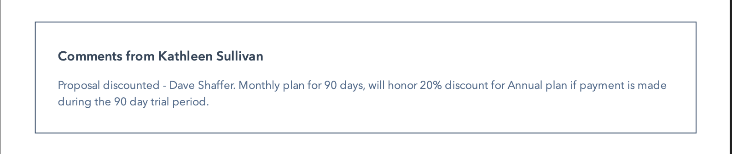
* 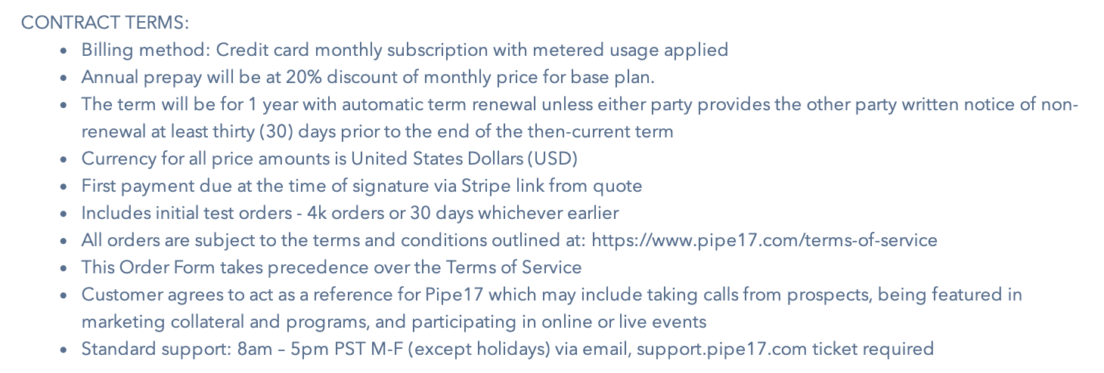

### 

### **Prorated Add-Ons (Mid-Term Additions)**

* This applies if the contract says add-ons will be prorated
  + [Example](https://garage.tabsplatform.com/prod/contracts/6045c858-9255-4694-b8d7-c574b735c661/terms/revenue)
* Prorate the line items that it identifies and prorate on a monthly basis
* For example if the add-on covers 10 months out of a 12 month term, multiply the line items by (10/12)

1. How do we handle taxes as a line item?
   1. If None Listed, Ops Default is every tax line item becomes a BT

### Events Processing (if necessary) *(Entire Section: Implementation/Success to fill Post-Go Live)*

* Any important information on events billing

Integration Items Processing (if necessary)  
*(Entire Section: Implementation/Success to fill Post-Go Live)*

* What are the instructions for assigning integration items?
* Example: All Statsig integrations items should be labeled as “Sales”
* Example: All “Pinata” integration items should be labeled as “Software Subscription Bundle” unless otherwise noted by Merchant

Post Processing Communications (if necessary)  
*(Entire Section: Implementation/Success to fill Post-Go Live)*

* Does the Ops Team need to notify anyone on the team re: completion of processing batches in Implementation or Active phase?
* Who needs to be notified and when?
  + Example:
    - Who: Customer Success [Azmat Aziz] needs to be notified
    - Where: Messari internal merchant channel
    - When: contracts are processed [Merchant Phase: Active]

### Customer Information *(Entire Section: Implementation/Success to fill Post-Go Live)*

* Any important information on specifics customers of this merchant
  + Special memo’s certain invoices require
  + Invoice changes due to merchant/customer relationship

### Feature Requests *(AE to fill for all requests prior to Imp handoff, Imp to fill prior to go-live/Success to fill to fill Post-Go Live)*

* FR 1
  + What is it: **Update Stripe data via Tabs.**

They want to push Tabs invoice/payment data to their Pipe17 app (Pipe17 app has a payment portal leveraging Stripe payment rails) For any updates made to the customer’s account, we need to be able to push that update to Stripe.

* + Why it's important: customers pay via Pipe17 portal and see their info in Pipe17- they want to maintain this seamless experience
  + Urgency: Priority
* FR2
  + Parent child

There will be events across both the parent and child levels. They want to bill the parents based on the child and parent events. 2 options for tabs to handle this:

**Option #1:** Pipe17 is responsible for aggregating the child events and sending to us so we can bill the parent.

- this is preferred (we don’t have to build anything)

**Option #2:** Pipe17 sends us all child events and Tabs will aggregate to the parent level.

- this will take us 2 days to build and test

* FR3
  + MRR reporting
  + Not as urgent as FR1

### Merchant Calls *(AE to fill for all videos prior to Imp involvement, Imp to fill prior to go-live/Success to fill to fill Post-Go Live)*

Intro and demo: <https://us-56595.app.gong.io/call?id=1584166054781462189&account-id=6597097703158607878>   
  
Kathleen sharing her screen on Pipe17 payment portal:  
<https://www.loom.com/share/a5339a9a3b314134aeb6cac2ec2d68d6?sid=d00f84e4-b1b5-4ece-91cd-117c65b26d91>

Technical validation : <https://us-56595.app.gong.io/call?id=7173441176989682448&account-id=6597097703158607878>

Partnership: <https://us-56595.app.gong.io/call?id=1882496550575645430&account-id=6597097703158607878>